**Pagination**

1. **Task Description**

Develop a paginated content component in React with navigation controls. The component should display data in pages with 'Previous' and 'Next' buttons, along with numbered buttons for navigation. It includes an ellipsis (`...`) for smoother navigation between distant pages, and it provides responsive updates based on user interaction with the pagination controls.

1. **Task Output Screenshot**

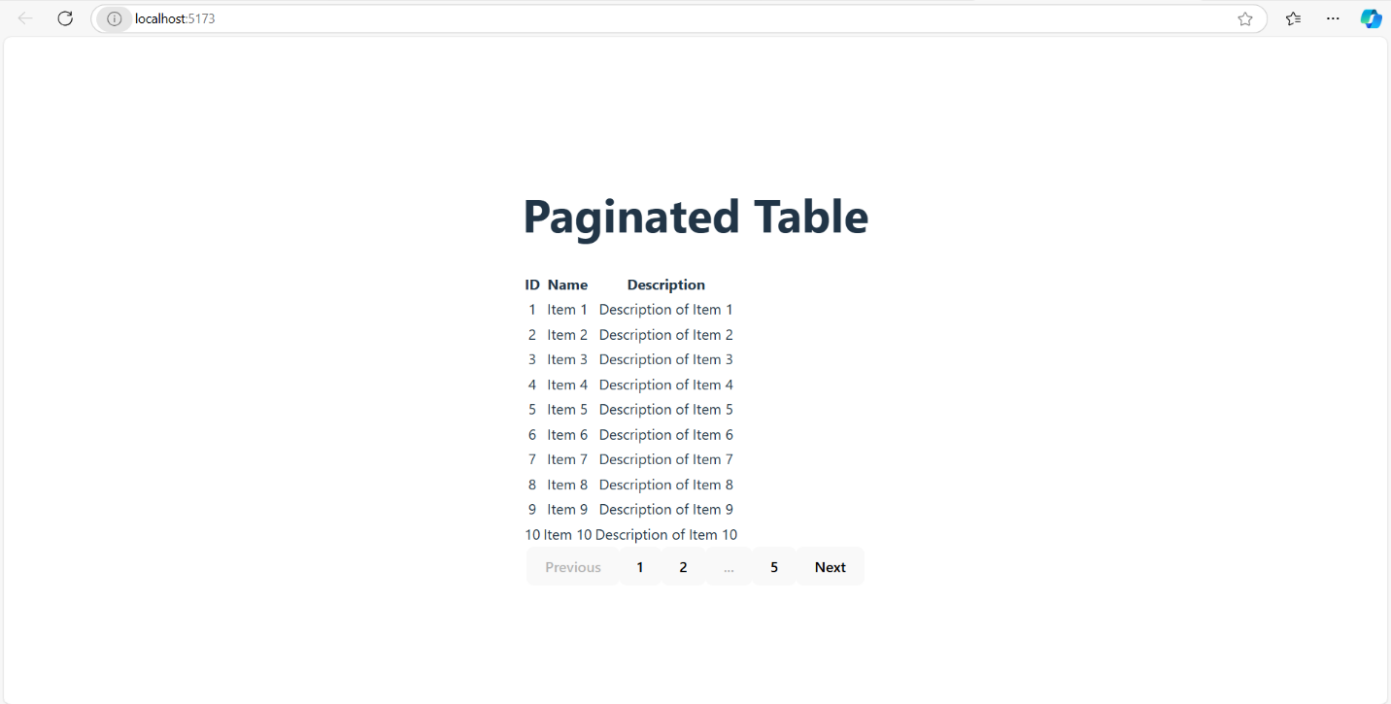

1. **Widget/Algorithm Used In Task**

1. Pagination Algorithm: Determines which page numbers and content to display based on the current page. It calculates and dynamically updates the visible pages, total pages, and handles edge cases for beginning and end pages, integrating ellipses for improved UX on long lists.

2. State Management: Uses React’s state to manage and track the current page, updating the displayed content and navigation buttons accordingly.

3. Event Handling: Implements event listeners on 'Previous', 'Next', and numbered buttons to allow smooth navigation between pages.